Government as a Platform – The Value Proposition
A discussion paper

Lab+ Experiment
Service Innovation Work Program
Department of Internal Affairs
June 2017

Many interactions with government are trivial, or administrative, like a visit to the doctor to be sure a minor issue isn’t something bigger. As soon as issues become even a little bit more complicated, they are often not resolved with a single visit.
A Story – How flipping a simple switch saved a lot of time and money

Frequently a caregiver, counselor, doctor, physio, claims processer, etc. will review an application, make an assessment, determine a course of action, and then get approval for funding or next steps. Approval processes like these are part of many government interactions.

We’re used to these processes, and we’ve gotten used to waiting for approvals and results.

So it isn’t uncommon or surprising to any of us to hear about a process that includes searching for a provider… meeting for assessment… hearing that a request for approval is required… then making another appointment, perhaps elsewhere, with different evidence… or getting re-approval or assessment if treatment or service is ongoing.

We often don’t know that caregivers and other service providers can be required to fill out scores of data fields, sometimes on paper, to get approval and funding to provide care or service. We often don’t think about the cost somewhere in government to review and decide on all of these requests.

For one service, a simple innovation changed the entire equation. An analyst in Wellington realised that for one service they provided approval for, only four data fields determined the approval process in ~95% of cases.

Others in the agency rallied around this discovery and went further – exposing these four criteria to their providers, alongside a few questions about risk. Processes and forms were changed to make it easier for qualified providers who could tick these boxes. Even further, they began investigating automation of the process that would allow caregivers to provide assessment, approval and service in the same visit.

This simple change, exposing data and a process, saved people time, reduced stress and uncertainty, reduced paperwork, and saved money for service providers and approval agencies. This change in approach is at the core of Government as a Platform, which is a more ambitious extension of this same idea.

Government as a Platform is about making certain data and decision rules of government open and available digitally and for use by others through an orderly and reliable platform. This paper is an early exploration of the value proposition for Government as a Platform to New Zealand.
Executive Summary

Incorporating a platform approach to service delivery enables civic and private sector actors to deliver additional convenience, function and service to meet the broad spectrum of public needs that government by itself could not.

The Apple appstore is one example of such a platform that enables orderly extension and contribution by others, while GPS is just one existing example of Government as a Platform.

For government itself the benefits start with short-term cashable savings and averted costs. Trials show reduced call centre contacts, lower staff contact, and more rapid processing of requests. The scale and scope benefits in moving from trials to a broad Government as a Platform approach are much larger, as government could use common data collection and management.
As other partners meet an increasingly diverse set of public needs, discontent with government is reduced. Government is enabled to focus its efforts strategically, and on what it does best.

For the public, time and convenience are important benefits. Certain life events require lots of government contact at once, which can be a negative experience if services are disjointed. This time impact can be large for those running a business, or managing amongst disadvantage.

The social benefits could be particularly high. Many disadvantaged New Zealanders are particularly time poor. Lack of time, stress and uncertainty are barriers to service, preventing the help we hope to deliver via government.

The economy benefits from enabling innovation and entrepreneurship. Government-enabled networks have been a foundation of productivity. Government as a Platform has demonstrated the potential to enable economic and public good.
Finally, if government does not adopt the tools driving economic productivity gains, it is forced to take a rising share of inputs or face funding cuts.

The Concept
Introduction – Government as a Platform

Many groundbreaking innovations have been platforms that enable others to interact, solve problems and meet needs that could not have been met solely by the platform provider.

Apple and the smartphone, and Amazon show the potential of building a platform that enables others to deliver far more, and to be more transformative, than the platform providers themselves ever could be.

These great platforms are not the Wild West, but are controlled, orderly and accessible. Platforms expose how to access, interact with and build on themselves to partners. An exceptional platform is enabling for partners, but it also enables the provider with controls, along with the ability to shape a core strategy and ensure that a core customer group is served consistently.

Government as a Platform is built from transparent, orderly, and digital access to:
- Decision rules of government,
- Transaction services, and
- Appropriate data obtained by and created from government activity.

Decision rules in government cover a wide range of contexts and domains such as how eligibility is determined, applications approved, or compliance determined. Transaction services cover a range of transactional interactions with government including registration, reporting or payments. Data covers a wide range of activities, inputs, outputs, and observations gleaned from these.

Just like the introductory story, Government as a Platform flips a simple switch. Instead of government taking all responsibility for every step of a process by default, government would start by exposing its data and decision rules where possible and be clear about its own delivery and complementary activities required to deliver government’s priorities. This approach removes government as a bottleneck, and enables others to uncover and meet particular customer needs.

A core role of government would be to:
- Create and guide an orderly and accessible platform, and
- Enable others to deliver alongside government and, where effective and appropriate, instead of government.

Government as a Platform in Practice

The examples to the right show how government data platforms continue to lead to surprising innovations. This openness and convenience is the benchmark people want, experience daily, and increasingly expect from government.

Lab+ and Result 10 research show that people get frustrated by searching across government for services and programmes, and providing the same information to different agencies when an important life event occurs. This demand is driving the integrated or federated services approach. One ambition for Government as a Platform is a common government information platform enabling government to hold and use common data itself.

Another ambition for Government as a Platform is a predictable source of appropriate government data, and the use of some automated decision rules. Open rules allow authorised parties to predict how they can make interaction with government timely, tailored and effective. Transactional services enable the public and providers integrated, common solutions for common tasks. Together these tools enable innovation from private and third sector parties.

Examples – Government Data Platforms

We use the Global Positioning System (GPS) every day in an increasing number of ways. GPS-enabled systems let us find directions, find our friends and find good takeaways. GPS is also used in sport, agriculture, supply chain management, analysis of complex movement patterns, and for geocaching.

GPS as a government-created, data-providing platform has allowed others to deliver value its creators never imagined.

Decision rules are often exposed to a degree in tax policy, with authorised parties able to provide services with added convenience to customers.
Weather data is obtained by government for its uses, is provided as a platform, and ends up in an array of smartphone apps, helping us plan our route to work and pack for our holidays.

More recently, several cities around the world have exposed food safety grading and processes, allowing them to be automatically incorporated into Yelp reviews in those cities
Government provided infrastructure has been critical to advancing the public good. It is possible to crowd onto the head of a pin about when it is the best role for government to create such platforms, but it is generally agreed to be when, once the infrastructure is in place:
Government platforms have underpinned our prosperity

- People can not easily or effectively be excluded from using it, and
- One person’s use doesn’t decrease the benefits available to others.

There is rarely clear-cut certainty (outside of providing a defense force), but a fully-fledged approach to Government as a Platform has a similar public good profile to other important infrastructure. Government-provided roads, sanitation and radio also have these characteristics, and each has been an economic and social boon.

Roads were the backbone network for the technology and growth opportunities of another era. From 1950-1970, modern road networks provided a significant, sustained and measured productivity boost that has been confirmed across a broad range of industries. There is little doubt about the breadth of benefit from the road network, and its impact across the economy and society (along with some drawbacks!).
The internet itself is the canonical story of government enabling the next generation of productivity-supporting infrastructure. While the internet has transformed countless sectors, in the majority of cases, the benefits of a digital interaction with government are yet to be realised.

Government as a Platform can enable this potential for digital infrastructure in the public good. The potential magnitude of change is seen in the innumerable public interactions governed or directly provided by government each year and the roughly 30% of GDP represented by government to support these transactions, goods and services.

Like the road network, this infrastructure could enable others to understand when and how they can connect to government, to build extensions to the network it would provide, to use that network to enable a wide range of other objectives, and to understand how to stand on the shoulders of government to provide services that improve the experience of government for the public.

Also like other networks, it is important to consider when elements of “cost recovery” are sensible, and when they are likely to reduce the benefits arising from a public infrastructure network.
What is already possible can give us an idea about the potential
The myMSD Trial – A government transactional and business rules platform

myMSD is an online, smartphone-enabled product allowing MSD clients to perform common transactions such as viewing payment and debt details to declaring weekly wages and applying for hardship grants.

myMSD is part of a broader simplification programme to change the nature of interaction with MSD. Streamlining apply, assess, and pay functions is intended to make the experience less impenetrable and more empowering, which also changes the interaction with case managers.

MSD supported simplification by providing free data to access myMSD. The programme enabled GPs to send medical certificates electronically via a third-party front, which MSD are able to process. myMSD is deployed in a secure government cloud, linking back to MSD core systems via an exposed API. The innovations delivered via the simplification programme required a large IT delivery agency to work in different ways, and to resolve some challenging obstacles.

This programme also demonstrates that innovating alongside current delivery is feasible.

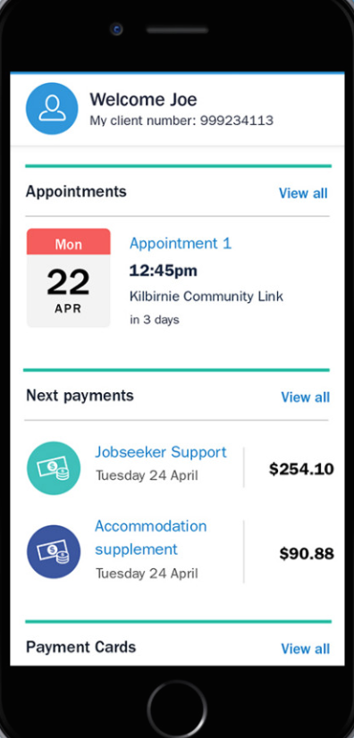
Concern about costs might be a barrier to innovation for some, however this programme has already generated several sources of savings, including cashable savings.

MSD was able to meaningfully change services while creating several benefits such as:
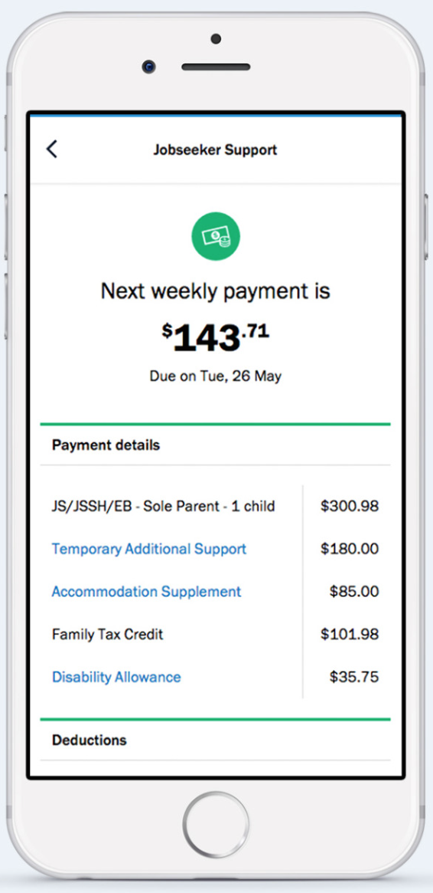
- The 60% of clients working part time that declare their weekly income through myMSD represent 11,000 transactions, many of these would otherwise have been via a service centre or contact centre .
- 220,000 further contacts have been avoided with appointment changes via myMSD.
- 40,000 applications for hardship assistance were submitted via the myMSD process instead of other channels.
- 2.3 million letters viewed on myMSD (99% of users) enable MSD to avoid sending via post.

With so many sources of benefit and reduced pressure arising from just this programme, we wonder about the potential scale of benefit from a broad approach to government as a platform.
Our project has just begun, and did not have access to a full breakdown of myMSD and the simplification programme costs and savings. We would be interested in doing deeper dives into this and other examples. By using current experience and extrapolating to potential future approaches, we hope to further inform agencies re: costs and benefits of potential next steps.
What is the scale of potential benefit?
myMSD is applied to some MSD transactions. MSD alone carries out 10 million transactions per year across a broad range of application-based programmes.
Across government there is a further web of additional application based programmes.
What would the time and money saved be from programmes like myMSD, if scaled though a common interface across a broad ecosystem of services?

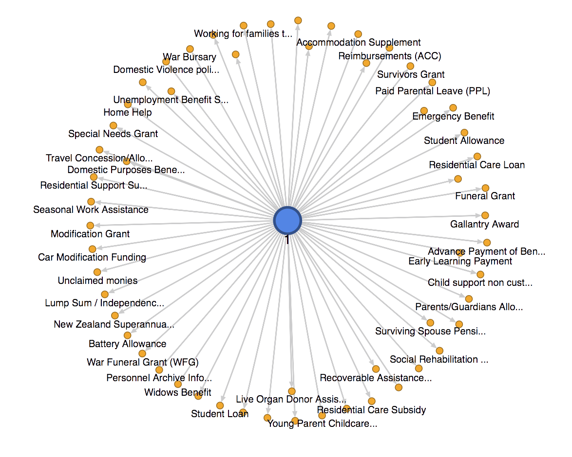
We observed that myMSD used a lightweight, agile approach, which will have limited upfront cost, and which could be simplified further if repeated by others.

We know that early benefit is not trivial. Reducing call centre load can save $2.50 per minute, which scales quickly in blocks of ten thousand multi-minute contacts weekly. We also know that the wrong kind of in-person contact prevents staff from focusing where benefit is highest. Avoiding these costs can help agencies to manage the growing service pressure they face. The actual averted costs, productivity benefits, and cashable savings are spread well beyond this narrow example, and could be extended further.
GOV

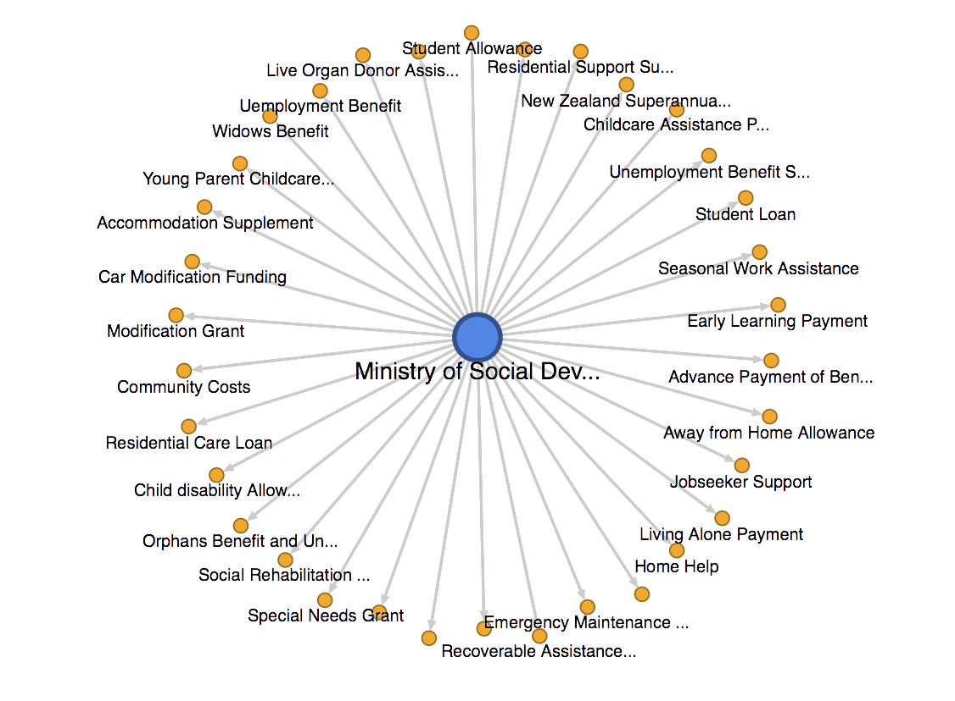

myMSD and similar products provide time, which is scarce for many in poverty, and peace of mind, both of which result in better uptake of critical services. In this way, ease of delivery can be almost as important as the service itself.
Social benefits from Government as a Platform
The myMSD Trial

As we better understand the human brain, the costs of complexity are increasingly clear. Poverty or crisis interferes with long-term planning and executive function. When we need help is exactly when we need things to be easy.

DIA and Lab+ look at services through the lens of life events, because often, when people need government services, we often need several of them at once due to illness, injury, birth, death, divorce, change in job, etc.

More and more we are learning that these are the times we are least able to manage complexity. We have learned that, sometimes, when people can’t manage, the result is that they don’t get the service they need. In this way, products such as myMSD can be part of effective social service delivery.

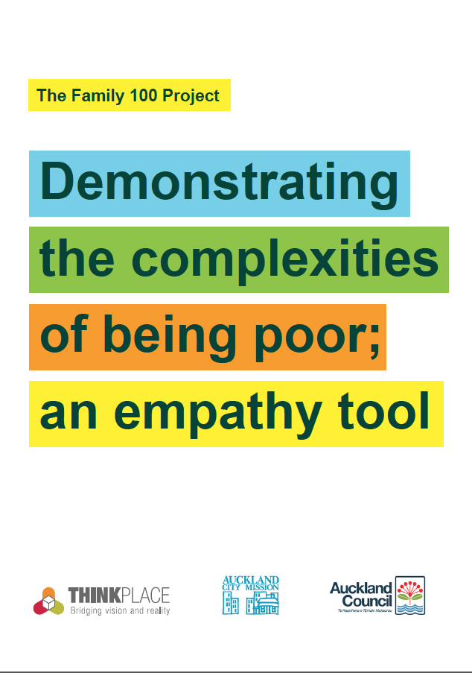
Those who use myMSD are now able to obtain information crucial to them whenever they need it. They can be certain of the information MSD has received, and they can avoid stress or uncertainty moabout whether vital assistance will be available.

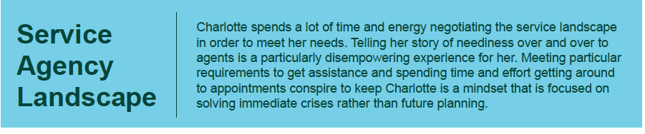
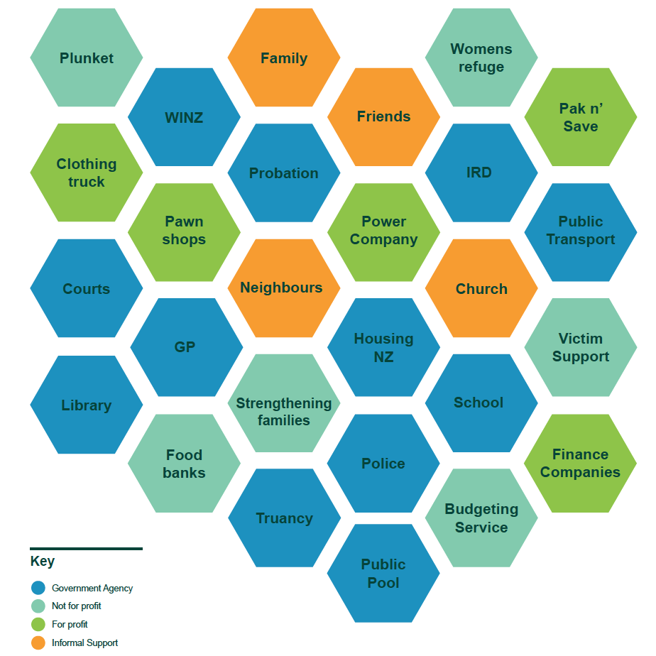
Perhaps most importantly, myMSD clients have avoided tens of thousands of visits to service centres. We heard about the previous frequency of repeat visits, in which additional information is required or paper-based forms must be obtained and delivered. DIA’s Rules Reduction programme found more broadly that misunderstanding of rules and regulations also leads to repeat or ineffective interactions with government. Resolving this provides time to the public and to agency staff.

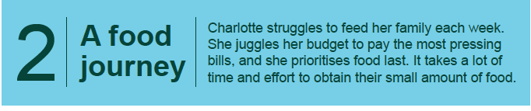
Several sources highlight the reality of very low discretionary income, which travel to receive service can further compromise. Standard dollar values of time do not capture trade offs when the alternative in time is an emergency food parcel.
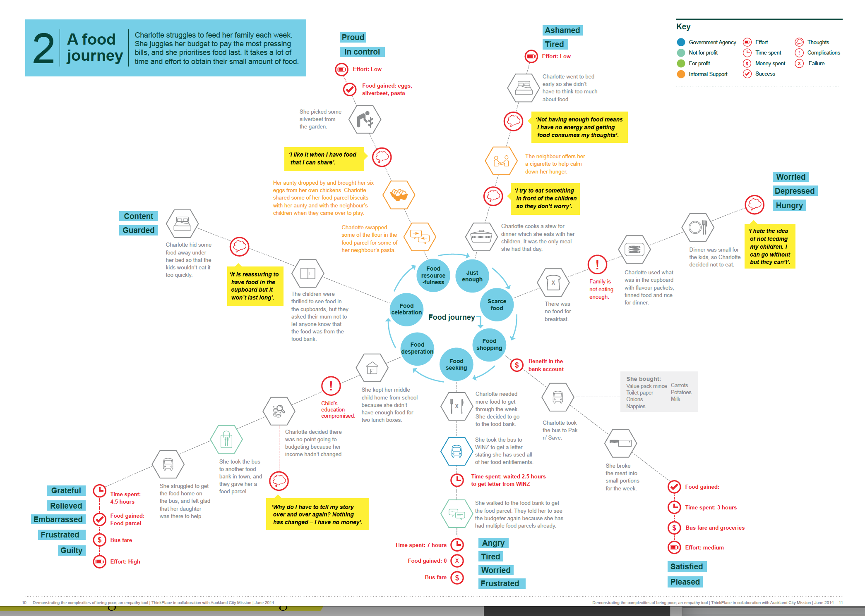
Deeper exposure into the experience of Poverty, such as that carried out by the Auckland City Mission and Thinkplace “Family 100” showed that deprivation is accompanied by a critical lack of time and ability to focus. This can impact benefit receipt.

The impact from simplicity on benefit takeup would be a socially important avenue to further explore.
Each year New Zealanders carry out tens of millions of transactions across levels of the Public Sector. Roughly 50,000 New Zealanders currently turn 65 every year, and 230,000 New Zealanders are soon to or have just turned 65, which our research shows is felt as a process, rather than as a single date.
Time Savings from Government as a Platform
The example of benefits for those 65 and over

When we turn 65 it has important implications for KiwiSaver and New Zealand Superannuation, while the process also includes a range of other considerations such as veteran’s benefits and pensions, and a range of superannuitant concessions, the Super Gold Card/Community services card. This can also be a time when health and employment considerations come to the fore.
In this example Chris faced unnecessary costs of $70 to obtain entitlements of $32 then $55 per week. More important is the delay in receipt and potential for some in a similar situation to miss out altogether because the right data and decision rules are not as available as they could be. These costs are in addition to the doctor’s time and agency staff time, not valued in our example.

There is no great service map, but there are a lot of people who need to learn a range of services, entitlements and the associated conditions (these are all business rules). This is a complicated period of high change, which is why Lab+ took an interest in people’s experiences during this process.

Our work considered the example of Chris, who in the simplest terms applied for a cash benefit, but along the way suffers the costs of repeated visits that could have been avoided, due to process uncertainty and additional information requirements. There are costs due to waiting, repeated processes, and an extra doctor’s visit. At the core of this example is a lapse in service at a service centre. This may not be a common occurrence, but in the future people could more easily resolve and avoid such circumstances.

In this example costs for Chris included:
- Six months of incomplete entitlement (=$600)
- A chance of missing a benefit altogether (say 50% post mistake, discounted at 7% =$4170)
- An unnecessary doctor’s visit, two unnecessary service centre visits and travel ($68.79 at standard time and travel costs)
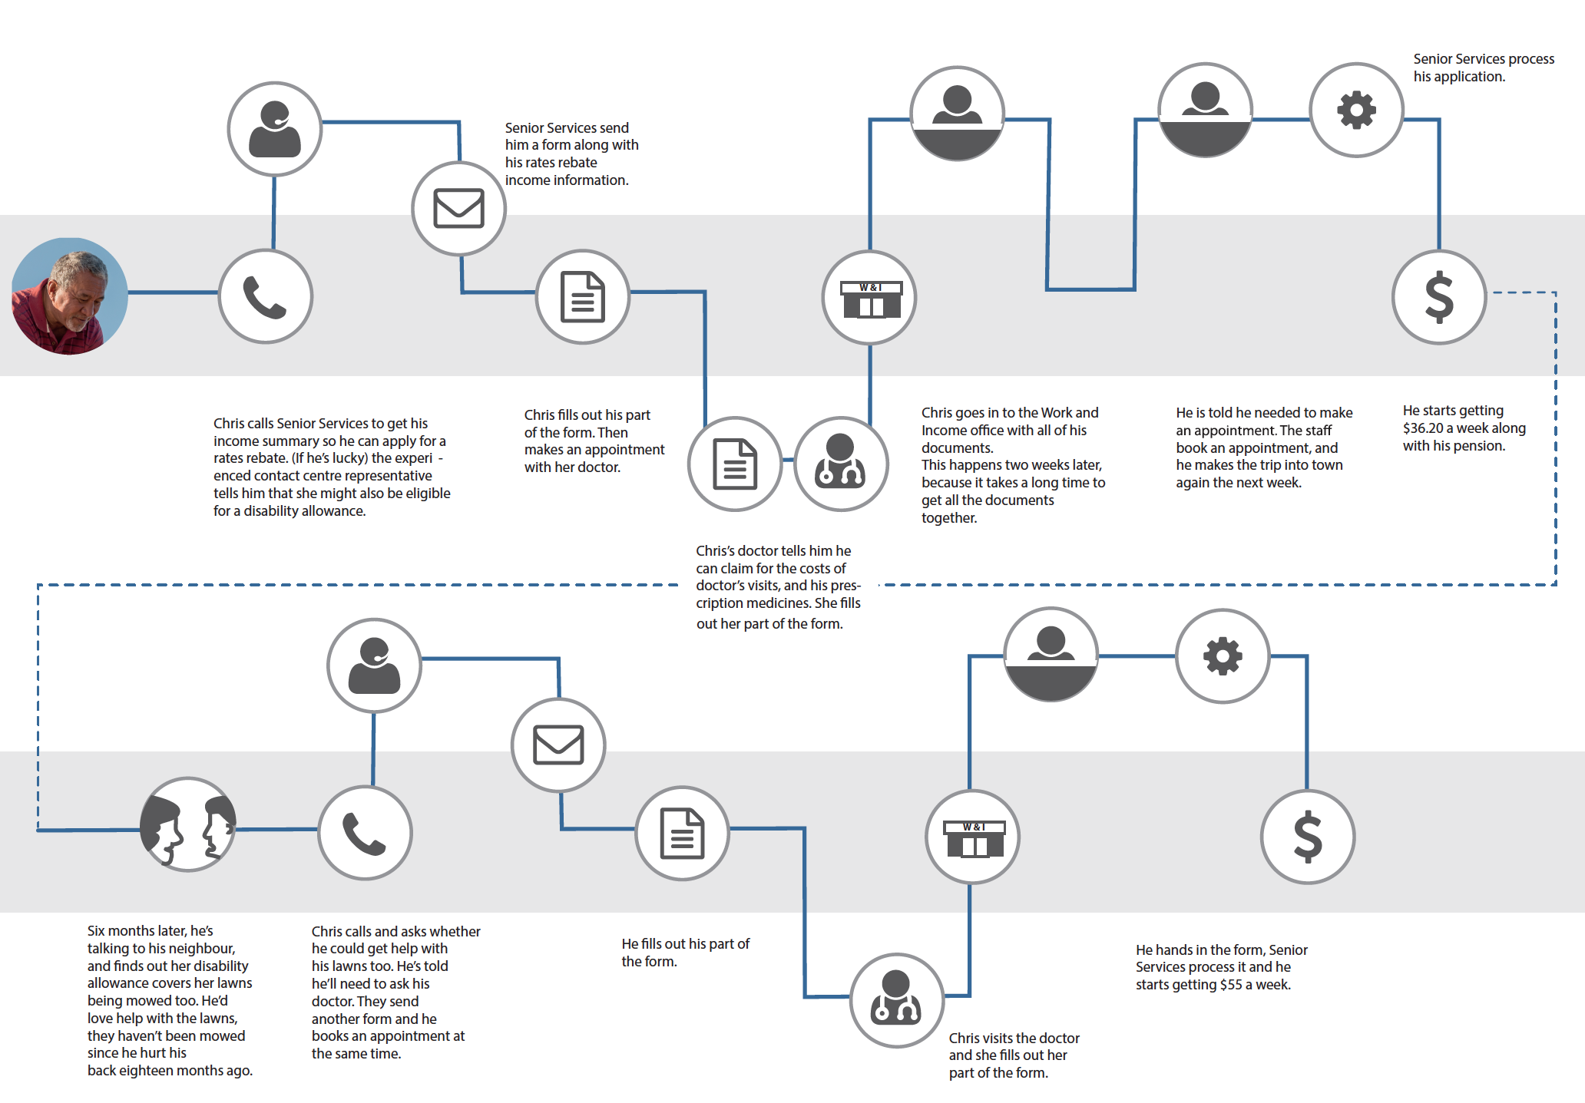
To value the potential time savings arising from innovations enabled by Government as a Platform, a different approach to time valuation is warranted.
Time Savings from Government as a Platform can also generate commercial benefit

Result 10 has provided useful estimates of the value of potential time savings across the population for reduction in forms and unnecessary meetings and travel. The Treasury’s Cost Benefit Analysis Tool (CBAX), provides values of customer’s time to be used in these calculations - $22.30 per hour based on average annual income.

Treasury’s values will be aligned with research by NZTA and the literature on the value of time savings, particularly in transport, which has explored a wide variety of approaches to valuing time for the population.

A recent vein of research connecting time spent commuting and personal well-being, life satisfaction and wider mental health suggest looking again at these figures for some contexts.

More importantly for this context, where Government as a Platform enables third party service providers, the evidence suggests that many of those who take up these services will predictably be those who value their time highly.
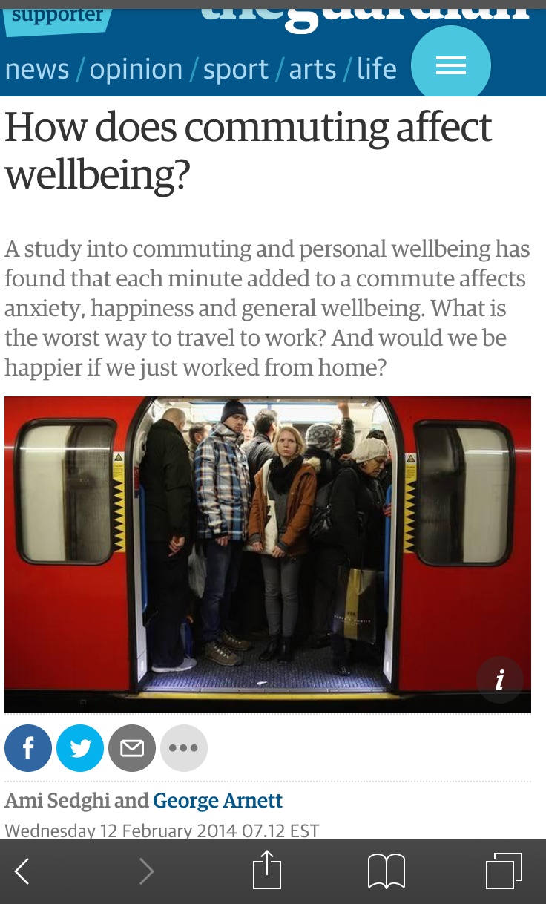
An average value for time is fine until a particular circumstance, like this one, draws people from one end of a distribution. In this case, examples from toll-roading and regional air travel in Australia show a significant proportion of the population with a willingness to pay well-exceeding the average wage rate for time savings.

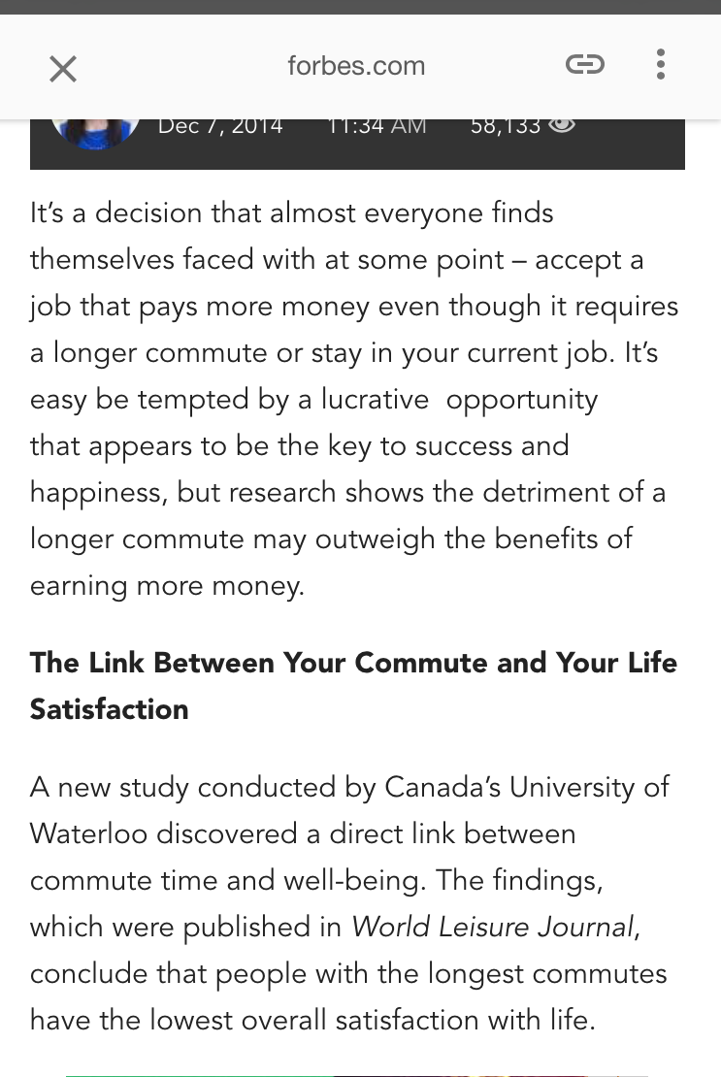
While income is not the only factor in valuing time savings, NZTA found that, at two-times average income, the willingness to pay for time savings is 40% greater than at average incomes.

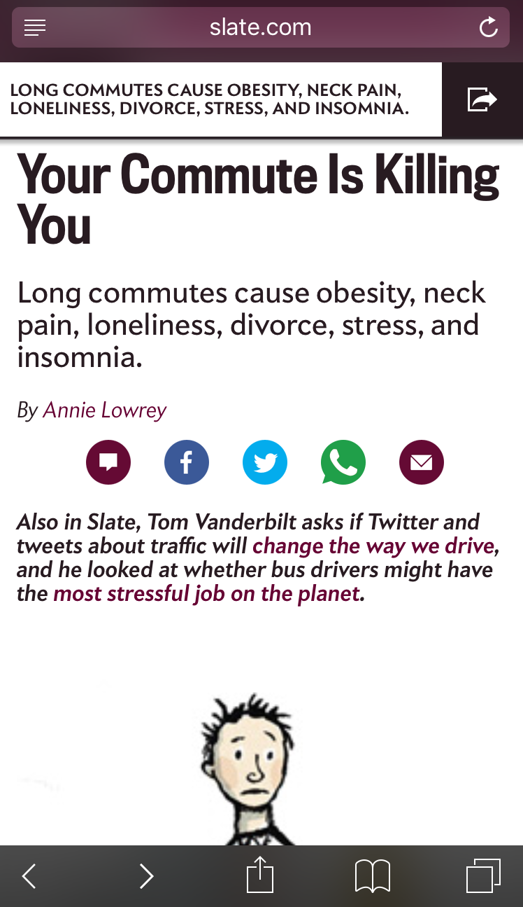
A study carried out in the presence of free alternatives, showed 11% of the population willing to pay for time savings, with a willingness to pay up five times higher than the average expected value of time savings.

Where time savings are gained from a commercial transaction, this higher willingness to pay creates tangible economic benefit (producer and consumer surplus for the parties). For government, the parties using alternatives to standard government service delivery would be those most likely to otherwise be frustrated by a lack of alternatives. One result of an alternative is likely to be increased esteem for government.

Valuing potential time savings

For this example, imagine a potential time-saving or complexity-reducing product, available from a third party via a Government Platform for a cost.

To determine the number of potential third party transactions we could start with the 3.119 million New Zealanders over the age of 25. Result 10 has indicated that in any year, 40% of these will undergo a major life event such as job change or loss, marriage, birth of a child, injury or illness, a death, etc. This is a group likely interacting with a range of government services, requiring similar transactions, at a point when time savings and reduced complexity would be at a premium.

For the purpose of estimating the value from these transactions, consider:
- The 40% of 3.119m New Zealanders facing a major life event (1.25m)
- 11% of these wiling to pay much higher than the average wage for time savings (137,500)
- An Australian example of $99 per hour for those with a high value for time, and willingness to pay for time savings.
- Start with the assumption of only a single hour saved across all of these processes.

These inputs generate a conservative value of time savings, and early-maturity commercial turnover of $13.6m per annum for each hour an innovative offering can save. This approach considers a life event during which time is at a premium, while research suggests that the time impost from government is high, across several service interactions. Given demonstrated willingness to pay, existing excessive use of time by current services, and demonstrated ability to address these costs, early commercial participation seems likely. Once costs are well under the average hourly value of $22, a much broader uptake and higher economic value would be expected.

As incomes increase, demand for time is following. Several retail surveys find a majority of customers willing to pay more for better, more convenient service, while two thirds want available self-service options. More studies about lack of time and well-being are likely to hurry this along.

Government as a Platform can provide benefit both via the time savings it provides and also by making a tangible economic contribution. It would be valuable to test this proposition further, exploring potential hours saved, willingness to pay in this domain and to further explore avenues of potential commercial and economic benefit
Government as a Platform allows government to join in productivity improvement
If government does not join in, then it will squeeze the economy, or be squeezed by it

Productivity is the driving force behind rising economic living standards over time. Productivity describes the innovations and improvements that allow us to produce more with the same or fewer inputs, including hours worked.

Right now, the private sector is using tools in common with the Government as a Platform approach to improve productivity and deliver the kinds of services to customers that the public demands from government.

Leading practices now allow companies to understand and engage customers about their potential needs using analytics and customer data. This is the kind of service Result 10 research shows that the public wants – the ability to understand individual needs and to help navigate a complex map of services. If government enables the data and the platform, the capability exists to enable these services.

Platforms are now the way providers enable an ecosystem to address complex customer needs. Single entities (like government agencies) delivering all supply chain functions themselves across a diverse customer base are a thing of the past.

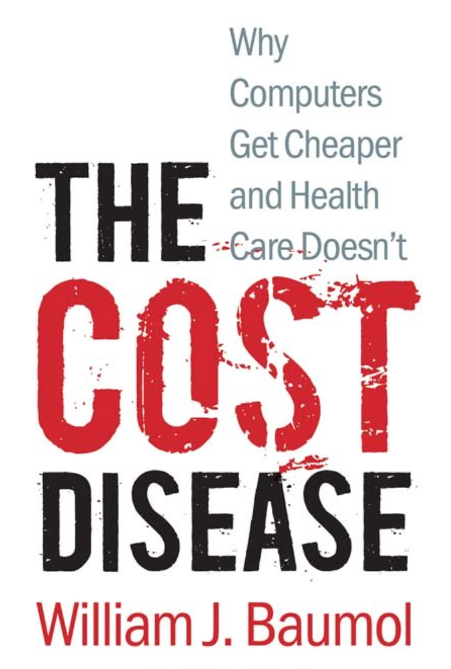
Gartner has found that businesses are now investing in customer experience more than any other area of marketing. These investments form the benchmark for public expectation. If government chooses not to incorporate these same tools itself, then it is choosing to be more and more expensive over time.

The economist William Baumol died on May 4 2017. Baumol predicted in theory, and then demonstrated empirically, that when one part of the economy does not improve its productivity, then either it must shrink, or take up an increasing amount of resource to produce a relatively more outdated output.

When government does not adopt the productive approaches of the broader economy, over time, it will continue to require the same inputs to achieve what it previously produced. The rest of the economy will have produced higher living standards and greater purchasing power. Government will still have to pay rents and salaries driven by higher living standards to produce an output at a level achieved in the past. The rest of the economy must either pay higher taxes for the same services, or reduce other government expenditure and services.
This paper provides an early exploration of the potential benefits from further developing the approach of Government as a Platform for service delivery. The benefits arising from further developing this approach come from a number of sources. The benefit levels appear to be aligned with government and agency priority and significant from early estimation.
Government as a Platform enables several benefits worth exploring in further detail

Critical considerations for agencies are ability to implement, the ability to generate cashable savings and cost avoidance to support investment in the near term. Estimation of even a narrow range of benefits shows that myMSD is clearly generating sources of both.

Recommendation 1: comprehensively set out the expected costs and benefits of following the myMSD approach, an understanding other agencies would find valuable.

The potential social benefits of Government as a Platform aren’t captured by current approaches. Current understanding of the impact on decision-making from the stress of disadvantage or amidst major life events provides an important motivation for simple, accessible and digitally supported interaction with government.
Recommendation 2: explore the impact of products on access to and the uptake of social services. Incorporate estimates of this effect into the potential value of Government as a Service.

Likewise the largest source of value in the example of Chris, (65 or older) arises from the potential for services not to reach those for whom they are intended.
Recommendation 3: Continue to develop and test “Help me Plan” products with the potential to assist navigation through government entitlements and services.

There are further avenues commercial potential to explore and quantify. Recommendation 4: estimate potential reduced costs of customer acquisition and resulting economic impact.

Finally, Recommendation 5: it would be worth outlining critical productivity improving practices in the private sector aligned with Government as a Platform to determine where gaps may be arising, which could make critical government programmes less affordable over time
Selected references available on request

