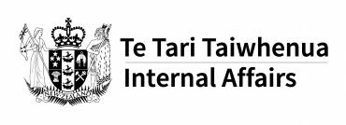

A research report:
What is digital inclusion like for disabled people?

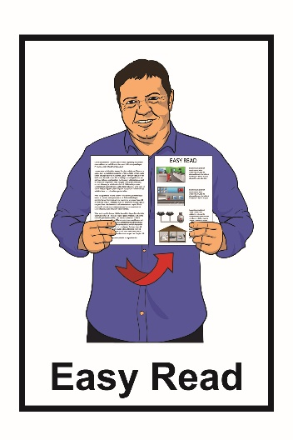

November 2020
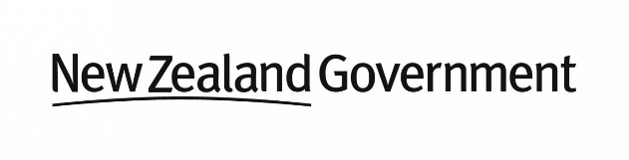
What you will find in here

Page number:
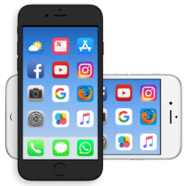

What is digital technology and
digital inclusion?...............................2

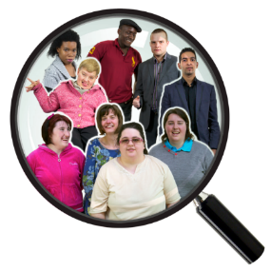

What the research looked at………..6

What we already know about
digital inclusion……………………..10

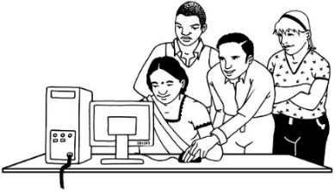

What the research found…………..19

What needs to happen next?..........22
What is digital technology and
digital inclusion?

We live in a world where lots of people use digital technology every day.

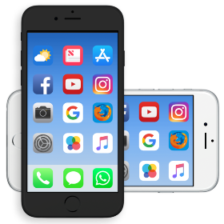
Digital technology means things like:
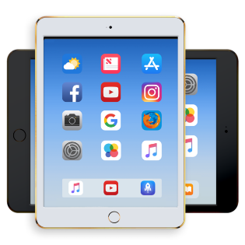
- smartphones or mobile phones
- computers or laptops

- iPads or Chromebooks

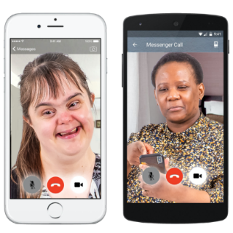
- the internet
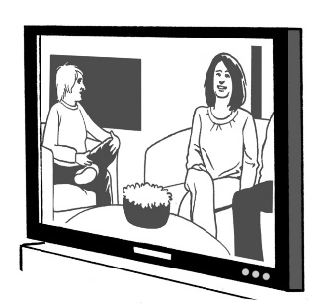
- video calling like Zoom or Skype

- smart televisions.
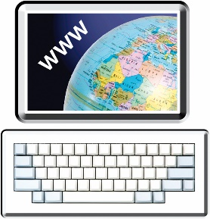
Sometimes we use digital technology to do jobs for us like:

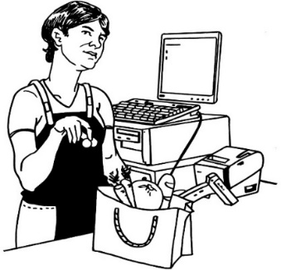
- putting information about government services on websites
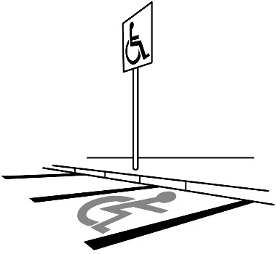
- self-checkouts at the supermarket
- parking meters collecting money for parking
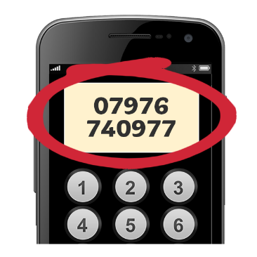
- remembering phone numbers
- finding places when we go out
- heating our homes
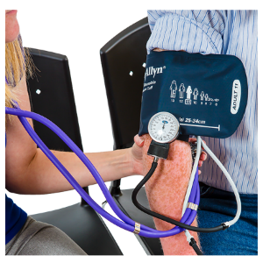
- keeping us healthy with medical devices like blood pressure machines.

Digital technology is a big part of our world.

It has changed many of the ways we do things.

Digital inclusion is when digital technology is made so people can easily:

- get access to it
- use it.

Digital exclusion is when digital technology is:

- not made accessible for everyone

- too hard to use.
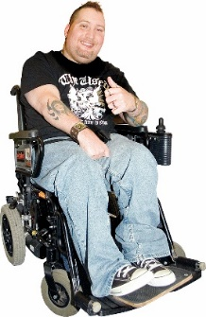
Accessible means:

- that disabled people can easily use digital technology
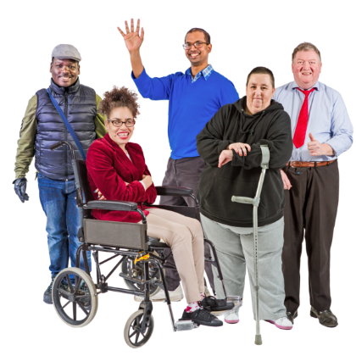
- digital technology is made in a way that everyone can use it.

What the research looked at
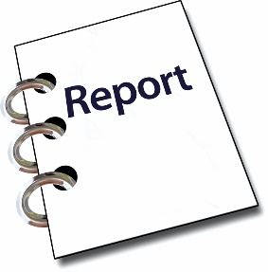
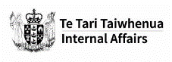

The Department of Internal Affairs has written a research report about digital inclusion.

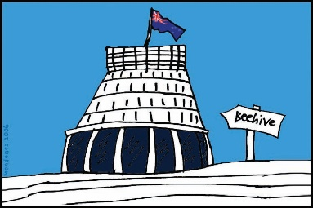
The Department of Internal Affairs is part of the New Zealand Government.

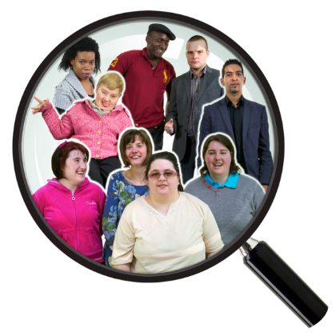
A research report is written by people who:

- look into something closely

- write about what they found.

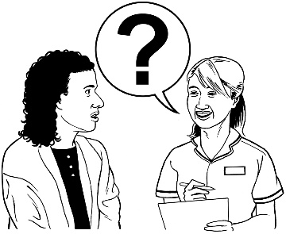
The research team asked people about their experiences of digital inclusion in New Zealand such as:

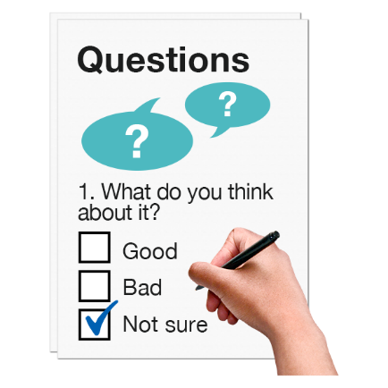
          - what they think about digital inclusion
          - their feelings about digital inclusion
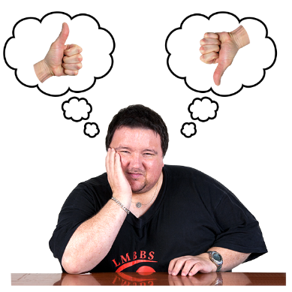
          - what they like about how digital technology is working now
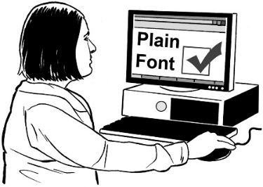
          - what they think needs to change in how digital accessibility works now
          - how digital technology could work better for their communities.

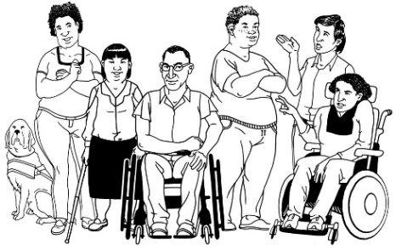
The research team talked to 27 people who were:

          - disabled people
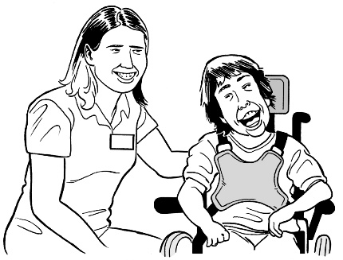
          - people who work in disability organisations
          - carers of disabled people.

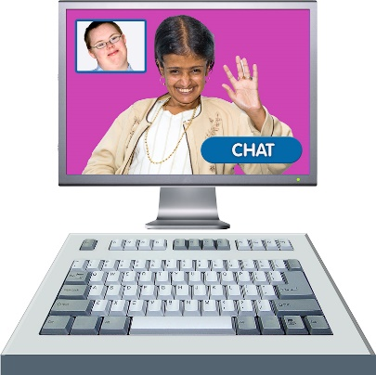
The research team talked to people:
- over the phone
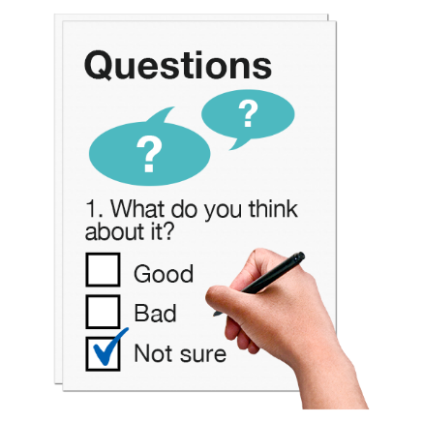
- by video calls
- in face to face interviews
- by them sending us written information.

COVID-19 made some parts of the research hard to do.

It was very hard to:
          - travel
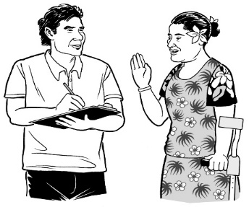
          - meet people in person
          - have face to face interviews.

What we already know about digital inclusion

We know that some groups of people find it hard to access digital technology.
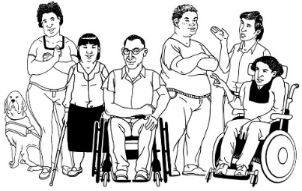

These groups are:
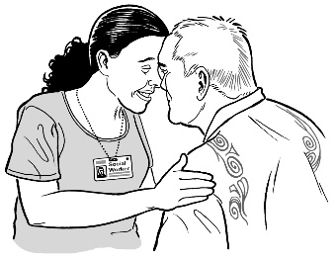
- disabled people

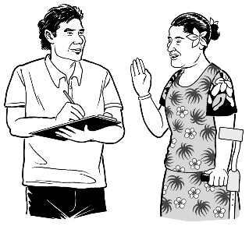
- Māori

- Pacific peoples

- people living in state housing
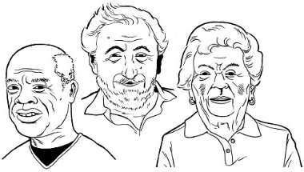
- older people.

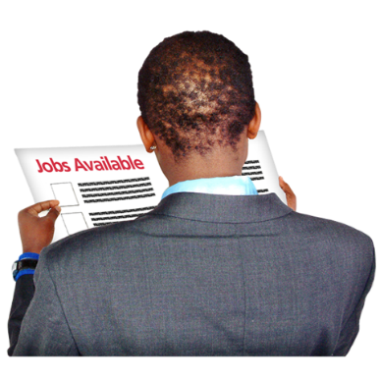
Other groups who find it hard to access digital technology are people who:

- are not working or do not have a job

- work part time

- live in rural communities outside of the city.

It can be hard for these people to access the services they need like:
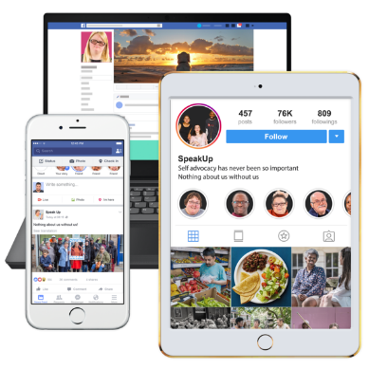
- online shopping
- social media like Facebook

- government websites to ask for support.

We also know that there are 4 important things that need to happen to make sure digital inclusion works.

These 4 things we need for a person to be digitally included are:
- Motivation
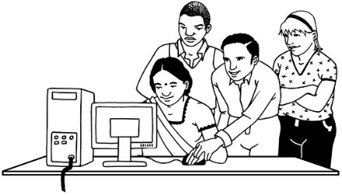

- Access

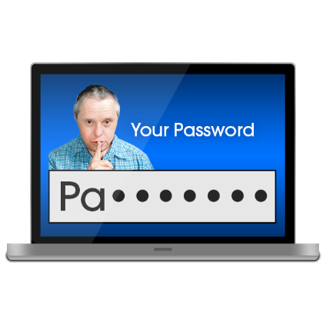
- Skills

- Trust.
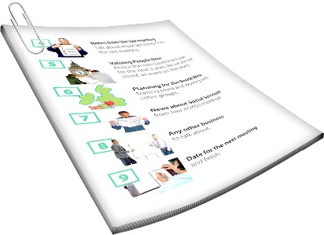
We will take a look at what each of these things mean in pages 13 to 18 of this document.

1. Motivation

Motivation is about people wanting to be part of the digital world.

People can be motivated by understanding that digital technology can support them with:

          - connecting with other people
          - their learning
          - doing things we could not do without digital technology.

This can give us good reasons to be part of the digital world.

2. Access

Access means being able to use digital technology when you need to.

You may want to access things like:
- the internet when you are:
- at work
- at home
- in the community
- devices like iPads
- digital services like online shopping.
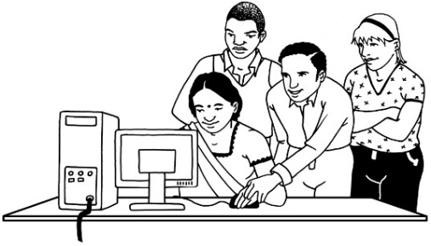
Access must also:
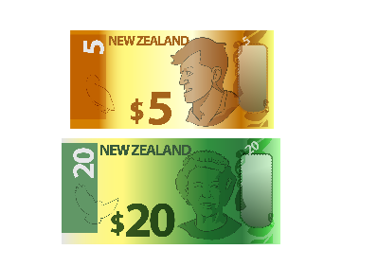
- work well for everyone who needs to use digital technology
- not cost a lot of money to use.

3. Skills
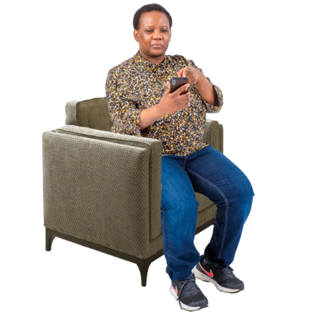

Skills means knowing how to use digital technology in ways that are good for us.

Skills are being able to use things like:

- internet
- digital devices like iPads
- tools like screen readers which make devices easier to use for some people to use.

4. Trust

Trust means feeling that the online services you are using are safe.

You need to be able to trust your services by knowing how to protect your personal information such as your:
- address
- phone number
- passwords
- banking pin numbers.

You need to also trust your services by learning how to know what is dangerous online like:

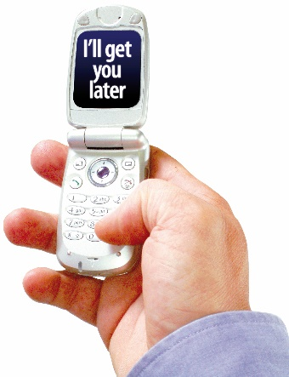
- scams
- online bullying
- what is not true online.
What the research found

After the interviews the researchers looked at all the information they had collected.

They made a list of things that might stop digital technology from being accessible to disabled people.

Some of these are:

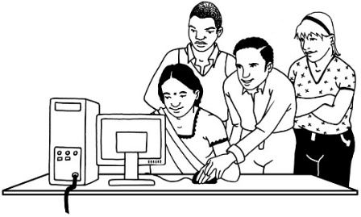
- the internet is still not very accessible

This Photo by Unknown Author is licensed under CC BY-SA
- the internet not being very accessible means people do not keep trying to use it.

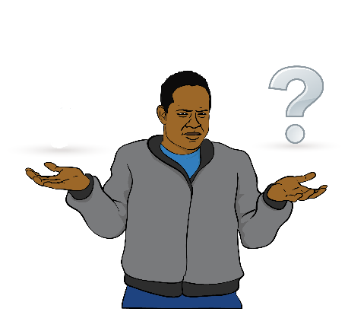
Some more reasons why disabled people may not find digital technology accessible are:

- not knowing if they can trust the technology they are using which means they stop using it
- businesses and government do not follow the rules on how to make their website accessible for everyone
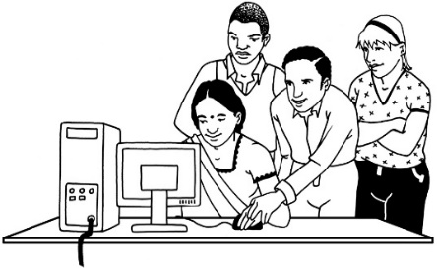
- using digital technology can cost a lot of money which means some people cannot afford it

This Photo by Unknown Author is licensed under CC BY-SA
- people need to learn how to use digital technology.

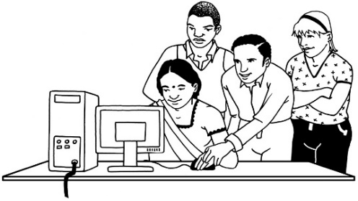
There is also not enough support about how to make digital technology accessible.

This Photo by Unknown Author is licensed under CC BY-SA

What needs to happen next?

The people interviewed said there are some things that they think need to be done to support digital inclusion.

The ways digital inclusion could be made better is by using the Web Accessibility Standard.

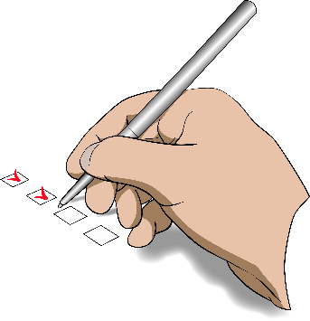
Web Accessibility Standard is like a list of rules about what is needed for making the internet accessible to disabled people.

Digital technology needs to be made to be accessible when it is made by:

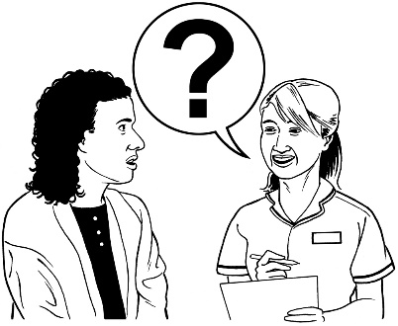
          - asking disabled people what they need to make technology accessible to them
          - making sure the people who make digital services:

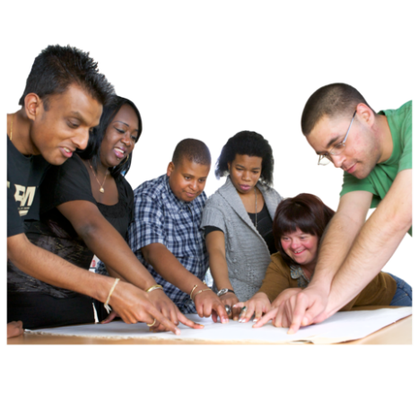
          - work alongside people who will use the digital technology
          - make something in a way that makes it easy for people to use.

.

Other ways digital inclusion could be made better are:

- have more ways for disabled people to learn how to use the accessibility tools in digital technology
- make digital technology cost less money for disabled people.

The researchers found that many disabled people need better access to:
          - digital devices
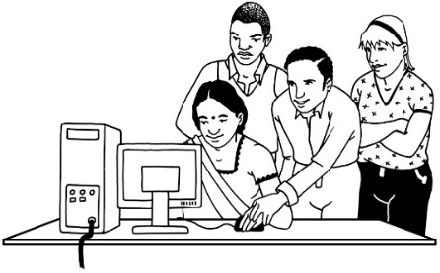
          - learning about how to use digital technology

This Photo by Unknown Author is licensed under CC BY-SA
          - accessible software
          - support to use digital technology.

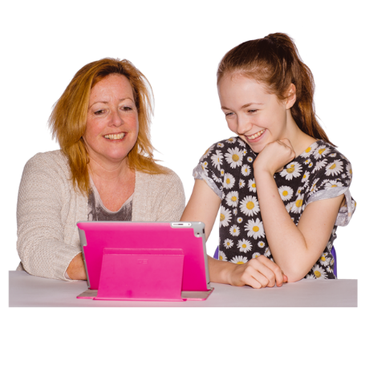
This needs to start when disabled people are still children so that they can use digital technology as adults.

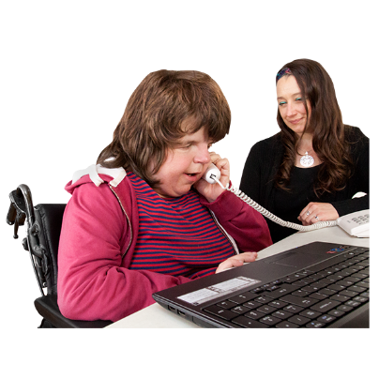
The researchers found that there needs to be more workplace support such as:

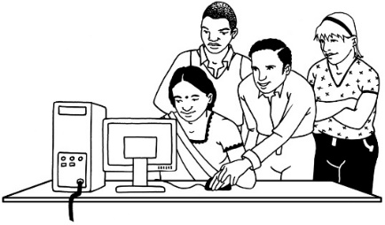
          - more ways to learn about the digital technology for work

This Photo by Unknown Author is licensed under CC BY-SA

          - workplace training that disabled people can do
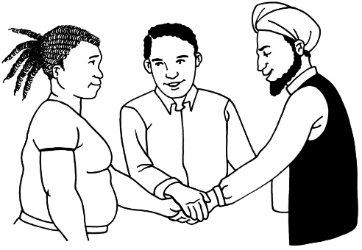
          - workplace training that support the inclusion of neuro-diverse people.

Neuro-diverse means that:
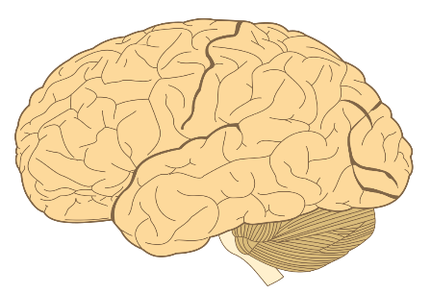
This Photo by Unknown Author is licensed under CC BY-SA
- the brain works in a different way

- the person learns things in a different way.

This report will be used to learn how to make New Zealand more digitally inclusive.

The research team would like to thank everyone who was part of this research project.
This Photo by Unknown Author is licensed under CC BY-NC-ND

The full research report can be found at this website:

https://bit.ly/35ZI3tv
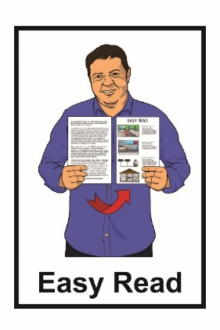
This information has been translated into Easy Read by the Make It Easy service of People First New Zealand Inc. Ngā Tāngata Tuatahi.
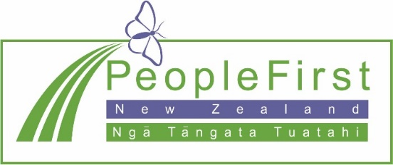
The ideas in this document are not the ideas of People First New Zealand Ngā Tāngata Tuatahi.
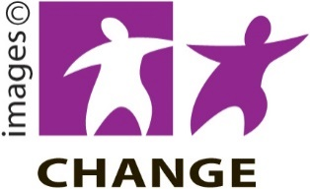
Make It Easy uses images from:

- Changepeople.org

- Photosymbols.com

- Sam Corliss

- Steve Bolton

All images used in this Easy Read document are subject to copyright rules and cannot be used without permission.

